# Graphs and Tables from the answers of the Taste Panel

Organized in the same order as the question form, with the English translation of the question at the top

Graph , What is your gender?

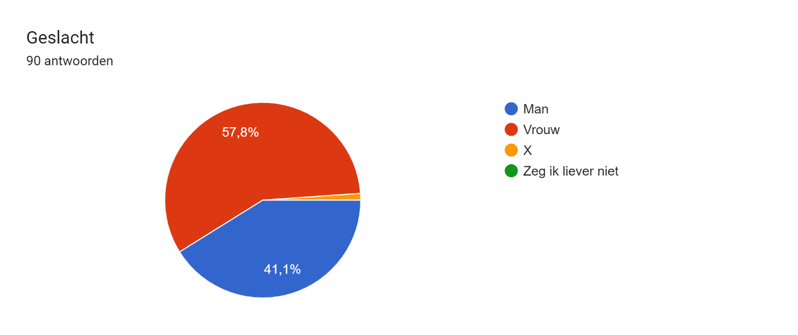

Graph , What is your age group?

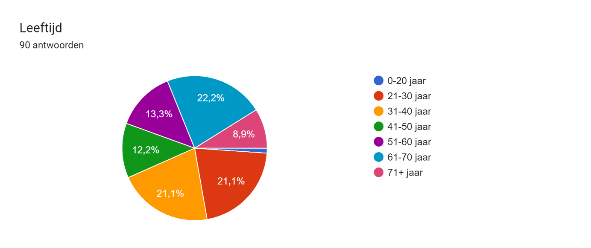

Graph , What is your favourite kitchen? Multiple answers possible.

Diagram met antwoorden op het Formulier. Titel van de vraag: Wat is je favoriete keuken? 
Meerdere antwoorden mogelijk. Aantal antwoorden: 90 antwoorden.

Graph , Do you eat Dutch dishes?

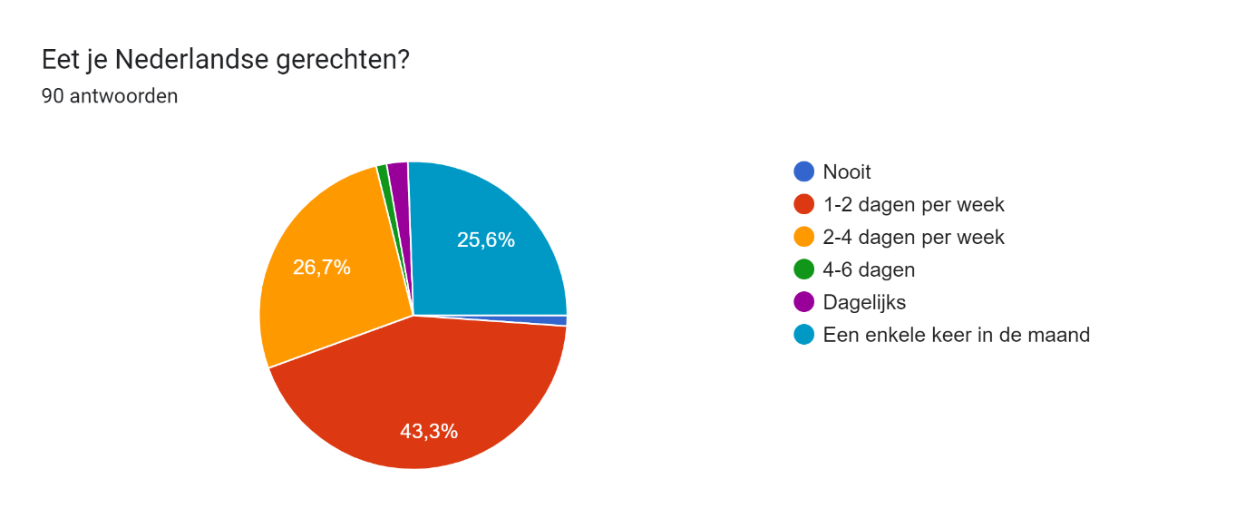

**Table** results from the question: Hoe zou je dit gerecht noemen/Welke naam zou je dit gerecht geven? (How would you define this dish/ which name would you give it?). The results were adjusted by removing all words as mini, and ‘-tje’ from the words pastei, quiche, taart and appeltaart so that these words would fall under the same definition.

|  |  |
| --- | --- |
| **Dish name** | **Quantity** |
| Pastei | 19 |
| Taart | 16 |
| Quiche | 8 |
| Appeltaart | 5 |
| Tartelette | 4 |
| Hartig taart | 4 |
| Gebak | 2 |
| Appelkoek | 2 |
| Appelgebak | 2 |
| Pastel de nata | 2 |
| Rozijnencake | 1 |
| volkoren taart | 1 |
| Rozijnpastei | 1 |
| Zoete mini pie met vulling | 1 |
| quiche | 1 |
| Gevuld pastei met bessen | 1 |
| Krentencup | 1 |
| Taart met krenten | 1 |
| Koekgebakje | 1 |
| Appel kaneel noten taart | 1 |
| Chocolade gebak | 1 |
| krentenpastei | 1 |
| Koek met vulling | 1 |
| Clementine | 1 |
| Hartig cake | 1 |
| Gevuld cake | 1 |
| Koek | 1 |
| Pudding | 1 |
| Appelpastei | 1 |
| Vleespastei | 1 |
| Appel/rozijnen koek | 1 |
| Appelbessentaart | 1 |
| Kaneel rondo | 1 |
| Luxe koek | 1 |
| Kruimeltaart | 1 |
| Appelrozijnengebakje | 1 |
| Volkoren appeltaart | 1 |
| vruchtenpastei | 1 |
| Halve appelbol | 1 |
| zoet pastei | 1 |
| Minced pie | 1 |
| tartellete | 1 |
| rozijnentaart | 1 |
| Gebak met appel | 1 |
| Flan | 1 |
| Gehakt | 1 |

**Table** , results from the question: Hoe zou je dit gerecht noemen/Welke naam zou je dit gerecht geven? (How would you define this dish/ which name would you give it?). The data has been adjusted by splitting multiple answers and adjusting some words to the correct spelling.

|  |  |
| --- | --- |
| **Dish Name** | **Quantity** |
| Taartje | 13 |
| Pasteitje | 9 |
| Pastei | 6 |
| Mini quiche | 4 |
| Tartelette | 4 |
| Pasteitje | 3 |
| Hartig taartje | 3 |
| Appeltaartje | 2 |
| Quiche | 2 |
| Rozijnencakeje | 1 |
| Mini volkoren tart | 1 |
| Rozijnpastei | 1 |
| Zoete mini pie met vulling | 1 |
| Mini quiche | 1 |
| Gevuld pasteitje met bessen | 1 |
| Krentencup | 1 |
| Quiche taartje | 1 |
| Klein gebakje | 1 |
| Taartje met krenten | 1 |
| Appelkoek | 1 |
| Koekgebakje | 1 |
| Appel kaneel noten taartje | 1 |
| Chocolade gebakje | 1 |
| krentenpasteitje | 1 |
| Appelgebakje | 1 |
| Koek met vulling | 1 |
| Clementine | 1 |
| Hartig cakeje | 1 |
| Gevuld cakeje | 1 |
| Koek | 1 |
| Pudding taartje | 1 |
| Appelpasteitje | 1 |
| Mini-appeltaartje | 1 |
| Vleespasteitje | 1 |
| Appel/rozijnen koek | 1 |
| Appelbessentaartje | 1 |
| Appelgebak renaissancestijl | 1 |
| Taartje | 1 |
| Kaneel rondo | 1 |
| Luxe koek | 1 |
| Kruimeltaart | 1 |
| Appelrozijnengebakje | 1 |
| Rustiek volkoren appeltaartje | 1 |
| Pastel de nata | 1 |
| Appeltaartje | 1 |
| Open pasteitje | 1 |
| vruchtenpasteitje | 1 |
| Mini-quiche | 1 |
| Halve appelbol | 1 |
| mini taartje | 1 |
| appeltaart | 1 |
| appelkoekje | 1 |
| zoet pasteitje | 1 |
| Minced pie | 1 |
| tartellete | 1 |
| rozijnentaartje | 1 |
| Gebakje met appel | 1 |
| Flan | 1 |
| Hartig taartje | 1 |
| Gebakje | 1 |
| Gehakt | 1 |
| pastel del nata | 1 |

Below is a pie chart of the same results from table , with the percentage of answers:

Table , Which Smell/fragrance do you recognize?

|  |  |
| --- | --- |
| **Smells/Aroma** | **Quantity** |
| Kaneel | 63 |
| Appel | 62 |
| Rozijn | 34 |
| Deeg | 15 |
| zoet | 11 |
| boter | 9 |
| appeltaart | 6 |
| suiker | 6 |
| Kruidnagel | 4 |
| zuur | 4 |
| Nootmuskaat | 4 |
| Specerijen | 3 |
| citroen | 3 |
| bloem | 3 |
| Speculaaskruiden | 3 |
| krent | 3 |
| Speculaas | 2 |
| Gist | 2 |
| fruit | 2 |
| vrucht | 2 |
| Noten | 2 |
| amandel | 2 |
| Gember | 2 |
| meel | 2 |
| vet | 2 |
| gebak | 2 |
| Kardemom | 2 |
| haver | 2 |
| Appelbaksel | 1 |
| Zoete appel | 1 |
| Amandelspijs | 1 |
| Appelflap | 1 |
| Taartdeeg | 1 |
| Kweepeer | 1 |
| Frambozen | 1 |
| Fruitig | 1 |
| rood | 1 |
| Citrus | 1 |
| Vijgen | 1 |
| Gedroogde gemberpoeder | 1 |
| fris | 1 |
| Licht ranzige boter | 1 |
| havermout | 1 |
| Rabarber | 1 |
| Anijs | 1 |
| volkoren | 1 |
| Koekkorst | 1 |
| Gekonfijte vruchten | 1 |
| Rum-rozijnen | 1 |
| brood | 1 |
| brooddeeg | 1 |
| Taai-taai | 1 |
| graan | 1 |
| gebakken deeg | 1 |
| bessen | 1 |
| kardemon | 1 |
| olie | 1 |
| koek | 1 |
| Broodpudding | 1 |
| zout | 1 |
| Rogge | 1 |
| Aards | 1 |
| Tarwe | 1 |

Chart , Which Smell/fragrance do you recognize?

Graph , On a scale of 1 to 10, how enjoyable is the texture/mouthfeel?

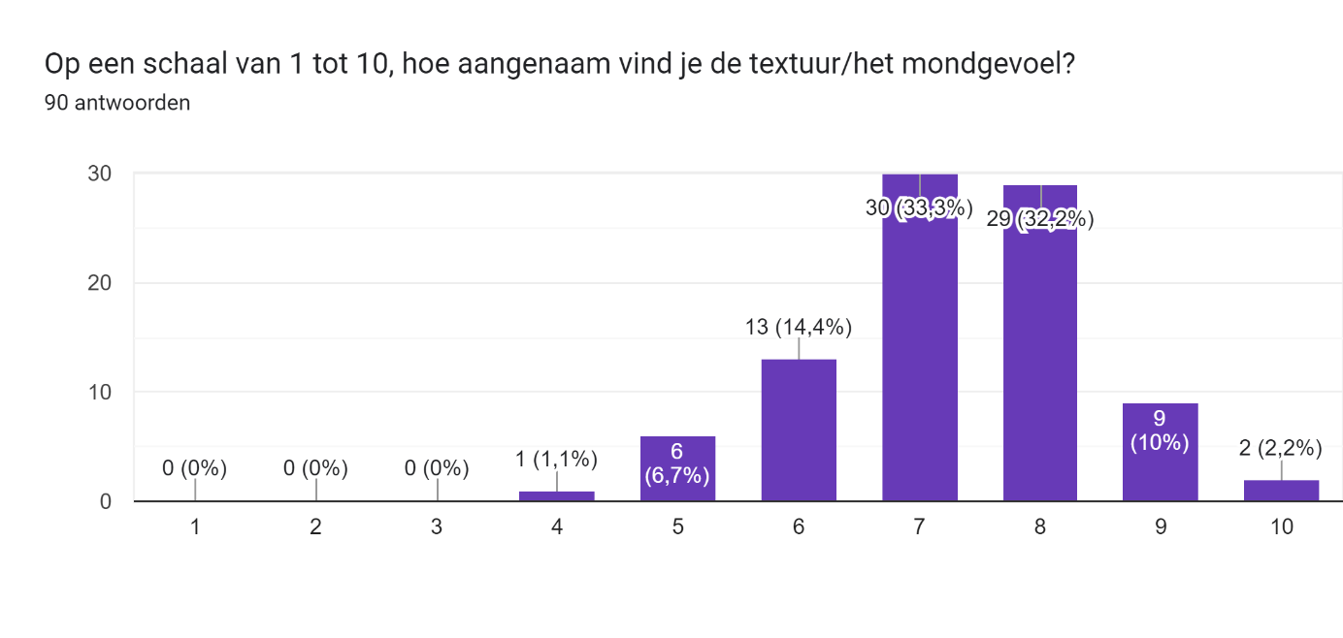

Graph , Which Textures do you recognize?

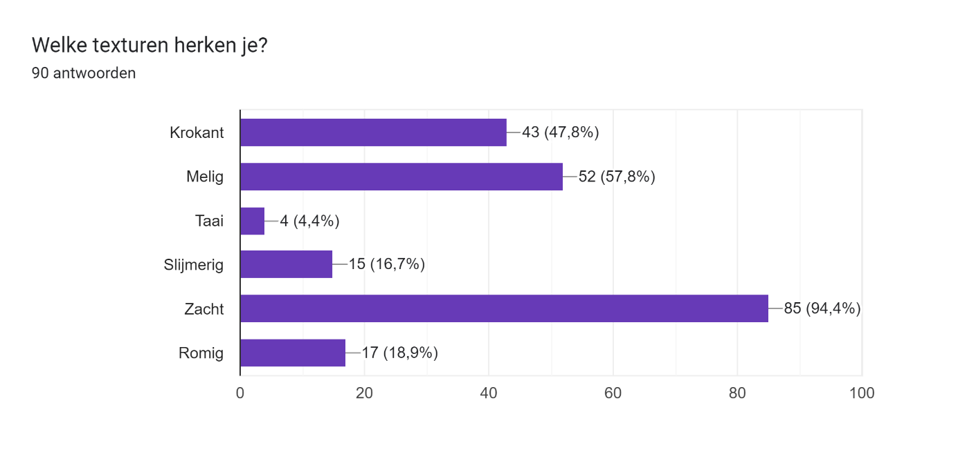

Table , Which flavors do you recognize?

|  |  |
| --- | --- |
| **Flavors** | **Quantity** |
| Appel | 46 |
| Zuur | 34 |
| Zoet | 30 |
| Kaneel | 28 |
| Rozijn | 25 |
| Deeg | 14 |
| Meel | 9 |
| Rozenwater | 7 |
| Suiker | 6 |
| Zout | 6 |
| Fris | 5 |
| Kruidig | 5 |
| Citrus | 5 |
| Citroen | 4 |
| Krent | 4 |
| Kweepeer | 4 |
| Bessen | 3 |
| Hartig | 3 |
| Specerijen | 3 |
| Graan | 3 |
| Bloem | 3 |
| Rabarber | 3 |
| Rozen | 3 |
| Bitter | 2 |
| Appeltaart | 2 |
| Neutraal | 2 |
| Kruidnagel | 2 |
| Koek | 2 |
| Kardemom | 2 |
| Vet | 1 |
| Appeltaart | 1 |
| Harde korst | 1 |
| Vrucht | 1 |
| Bloesem | 1 |
| Melig | 1 |
| Frisse/zure smaak appel | 1 |
| Heel licht zoet | 1 |
| Spicy | 1 |
| Lichtzoete specerijen | 1 |
| Zure besjes | 1 |
| Broodachtig | 1 |
| Gedroogde vruchten | 1 |
| Romig | 1 |
| Volkoren tarwe | 1 |
| Rogge | 1 |
| Boter | 1 |
| Baksmaak | 1 |
| Zoet, | 1 |
| Fruitig | 1 |
| Muf | 1 |
| Friszuur | 1 |
| Peer | 1 |
| Pittig | 1 |
| Volkoren meel | 1 |
| Adstringerend | 1 |
| Rinsig | 1 |
| Appel (zurig) | 1 |
| Nootmuskaat | 1 |
| Zoete appel | 1 |
| Zanderig | 1 |
| Zacht | 1 |
| Bloemigs | 1 |
| Lavendel | 1 |
| Gebakken bloem | 1 |
| Speculaaskruiden | 1 |
| Korst | 1 |
| Gebakken deeg | 1 |
| Lichtzuur | 1 |
| Soort custard | 1 |
| Fris-zure fruitsmaak (appel) | 1 |
| fruitig zoet | 1 |
| Zoet van Rozijn | 1 |
| Gewelde rozijnen | 1 |
| Alcohol | 1 |
| Volkoren taartdeeg | 1 |
| licht zuur | 1 |
| Appel | 1 |
| Ongezoet deeg | 1 |
| Fruitpap | 1 |
| Appelmoes | 1 |
| licht zoete smaak | 1 |
| Zuur en zoet combinatie | 1 |
| Zure appel | 1 |
| Amandel | 1 |
| Kruiden | 1 |
| Haver | 1 |
| Blauwe bes | 1 |

Graph , Which flavors do you recognize?

Graph , Which of the following predominates? (choose: Sweet, sour, salty or bitter)

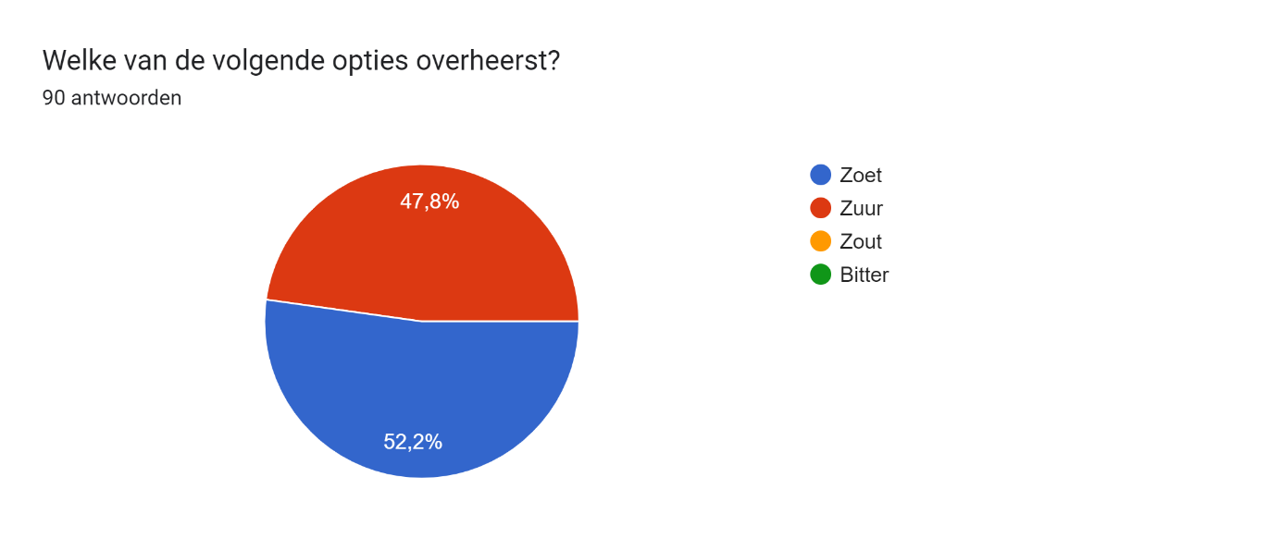

Table , Which ingredients do you recognize?

|  |  |
| --- | --- |
| **Ingredients** | **Quantity** |
| Appel | 78 |
| Rozijnen | 60 |
| Kaneel | 45 |
| Meel | 20 |
| Krenten | 17 |
| Suiker | 15 |
| Bloem | 14 |
| Boter | 14 |
| Bessen | 11 |
| Rozenwater | 10 |
| Zout | 8 |
| Citroen | 8 |
| Deeg | 8 |
| Kweepeer | 6 |
| Rabarber | 6 |
| Volkorenmeel | 5 |
| Volkorenbloem | 4 |
| Volkoren bloem | 4 |
| Specerijen | 4 |
| Peer | 3 |
| Korstdeeg | 3 |
| Volkoren meel | 3 |
| Jeneverbes | 2 |
| Rogge | 2 |
| Graan | 2 |
| Peper | 2 |
| Water | 2 |
| Rinse vrucht | 1 |
| Gember | 1 |
| Appelpuree | 1 |
| Kweepeerpuree | 1 |
| Vlierbes | 1 |
| Dubbelt met smaken | 1 |
| Appel | 1 |
| haver | 1 |
| Zuur | 1 |
| Munt | 1 |
| Taartdeeg | 1 |
| Dadel | 1 |
| Amandelspijs | 1 |
| Tarwebloem | 1 |
| Roos | 1 |
| Nootmuskaat | 1 |
| Ei | 1 |
| Sinaasappel(schil) | 1 |
| Kruidnagel | 1 |
| Pittige specerij | 1 |
| Boter | 1 |
| Citroen | 1 |
| Zuurtje | 1 |
| Aalbes | 1 |
| Meel | 1 |
| Volkorendeeg | 1 |
| Reuzel | 1 |
| Veg boter | 1 |
| Volkoren korst | 1 |
| Volkoren granen | 1 |
| Noten | 1 |
| Speculaaskruiden | 1 |
| Boekweit | 1 |
| Zemelen/volkoren | 1 |
| Citrusvrucht | 1 |
| Meel of bloem | 1 |
| Graan | 1 |
| Vulling gemarineerd in drank (rum) | 1 |
| Vanille | 1 |
| Kruisbessen | 1 |
| Citroenzuur | 1 |
| Lavendel | 1 |
| Citrus | 1 |
| Bloemen | 1 |
| Rozen | 1 |
| Zure appel | 1 |
| Blauwe bes | 1 |

Graph , Which ingredients do you recognize?

Graph , Which of the following terms apply to the taste of the dish? With terms taken from the book:

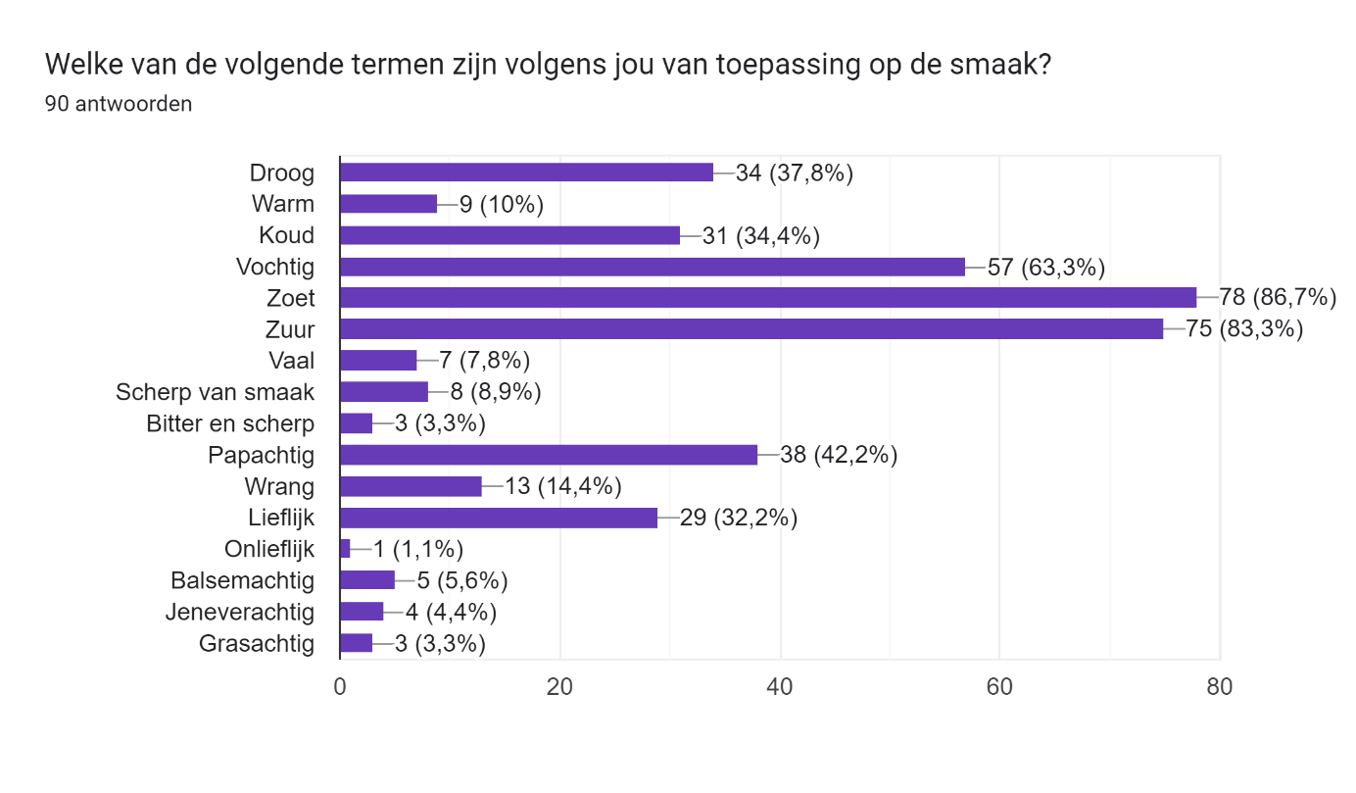

**Table** , Results from the question: Aan welk modern gerecht doet dit je denken? (Which modern dish does this remind you of? After tasting the dish). Words have been adjusted by splitting multiple answers in separate rows, spelling correction and removing some words as ‘de’,’een’ and ‘het’.

|  |  |
| --- | --- |
| **Dish name** | **Quality** |
| Appeltaart | 64 |
| Appeltaartje | 3 |
| Appelflap | 3 |
| Appelmoes | 3 |
| Rabarbertaart | 3 |
| Appelgebakje | 2 |
| Biologische Appeltaart zonder suiker | 1 |
| Appelgebak | 1 |
| Stiefmoeders Appeltaart | 1 |
| Zoet appel koekje | 1 |
| Frisse appeltaart | 1 |
| Spaanse / Portugese | 1 |
| Appelcake | 1 |
| Appeltaart met een droge korst | 1 |
| Biologisch gezond appeltaartje voor de slanke lijn | 1 |
| Appelfleur | 1 |
| Biologische appelreep | 1 |
| Appeltaartje met besjes | 1 |
| Mince pie | 1 |
| Fruitpap | 1 |
| Appeltaart van volkorenmeel | 1 |
| Appeltaart maar minder zoet | 1 |
| Havermout pap | 1 |
| Brood met zoetig beleg | 1 |
| Krentenbrood | 1 |
| Pannekoek | 1 |
| Krentenbol | 1 |
| Overnight oats | 1 |
| Pastel de nata | 1 |
| Britse mince pie | 1 |
| Marokkaans gebak | 1 |
| Haverkoek | 1 |
| Minced pie | 1 |
| Rum-rozijnen | 1 |

Below is the pie chart of these results from table , with the percentage of answers:

Graph , Under which meal time would you situate the dish?

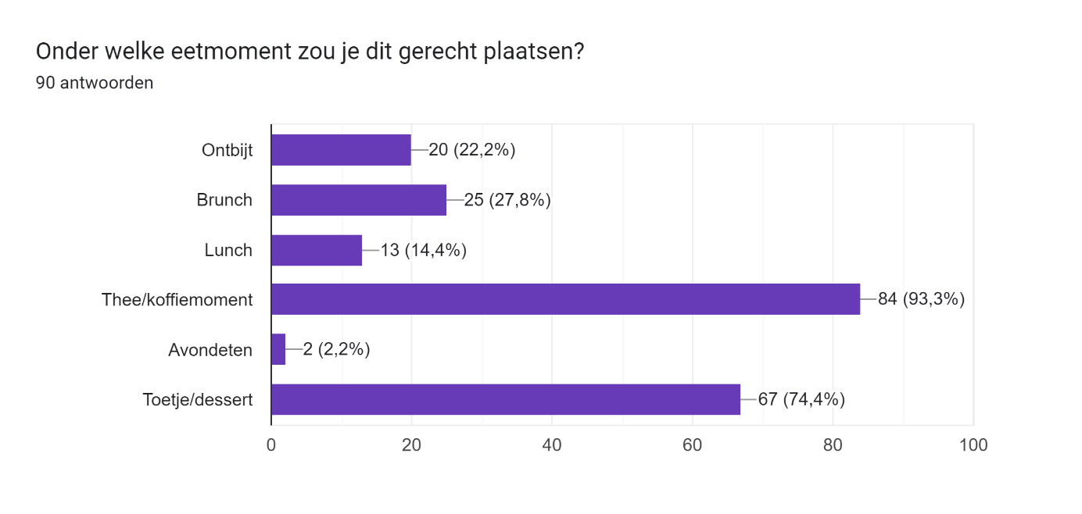

Graph , On a scale of 1 to 10, how tasty do you find the dish?

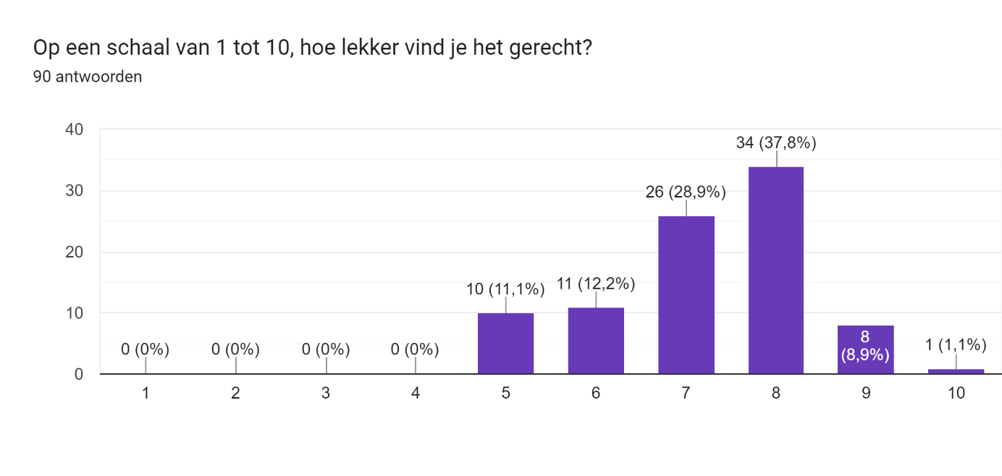

Graph , Would you eat this dish more often?

